**Level 1: PC Tower Case**

**Outline**

**Learn about the internals of a standard PC case by examining physical samples and selecting and labeling images found on-line. Gain deeper knowledge by researching and reporting on specific components.**

**Questions**

1. **Find one (or more) images that clearly show the internals of a PC Tower Case.   
   (i.e. Google images using keywords “PC Case Internals”)**

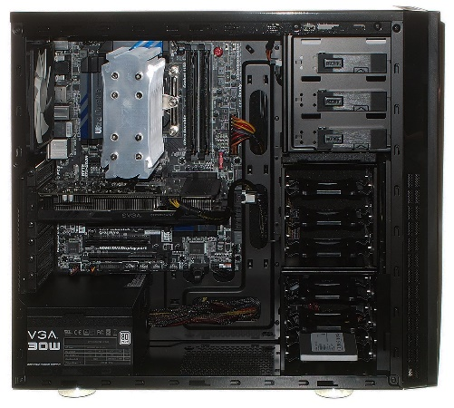

1. **Clearly label the following components (using arrows) on your image of the PC case internals:**
   1. **Motherboard**
   2. **Power Supply**
   3. **Hard Disk Drive**
   4. **Optical Disk Drive (e.g.DVD)**
   5. **USB Expansion Ports**
   6. **Monitor Port**
   7. **Audio Ports**
   8. **Ethernet Port**
   9. **Cooling Fan**

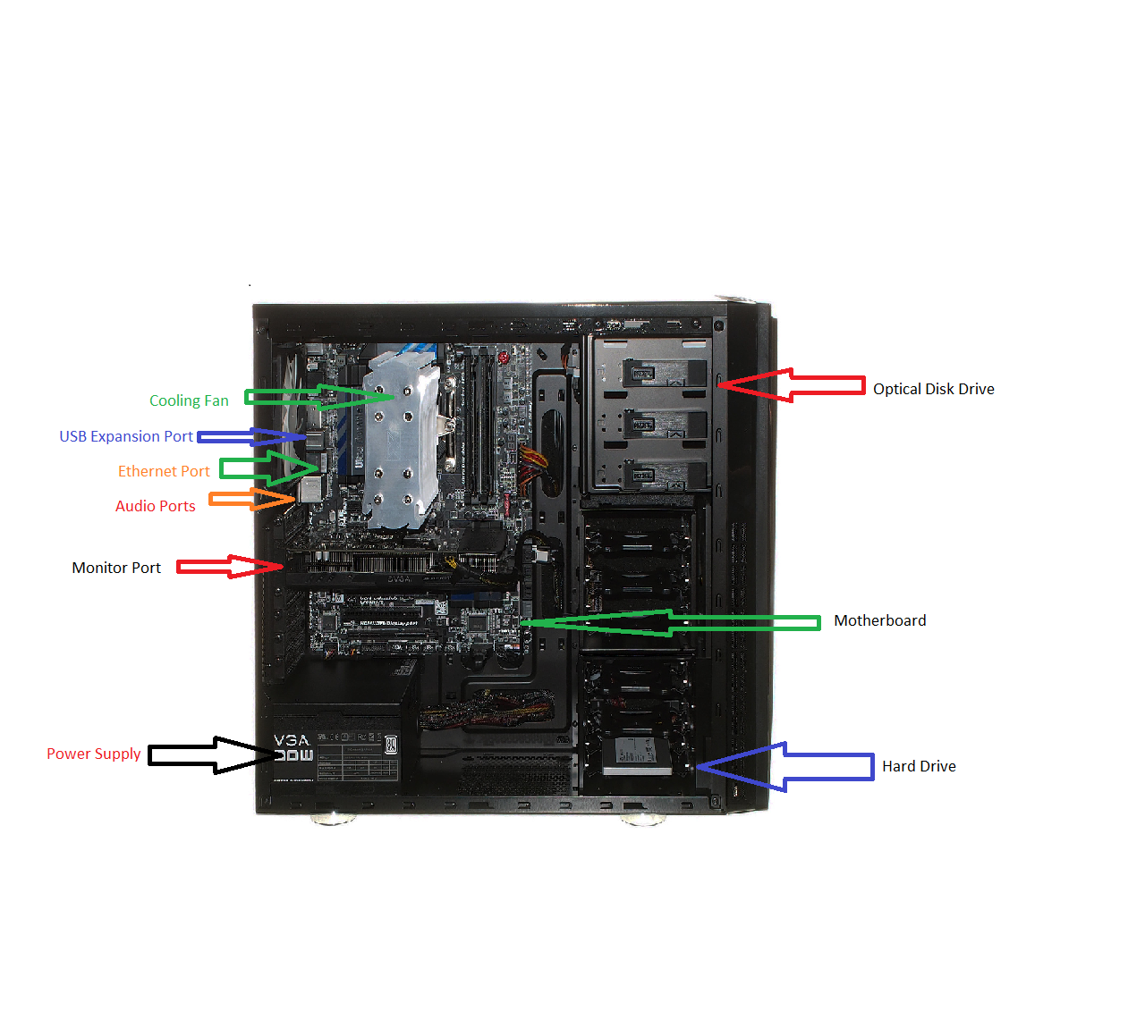

1. **Research more in-depth about “Motherboards”. Make notes on the following:**
   1. **What different versions are currently available (speed and capacity)**

**Currently, most desktops or laptops contain an ATX motherboard in which is the layout, design and size of the motherboard. However, motherboards do not form any sorts of speed due to its main function is to hold each of the ports, cables, processor and ram together.**

* 1. **How the component has changed since the 1980’s**

**The motherboard which was firstly known as the Planar Breadboard was brought into the technology world at 1981 by IBM. The Planar had chips which was only used to connect the CPU and RAM of the computer together. They were connected by cassette tapes and supplier parts. The Planar motherboard was also called the “IBM compatible” standard like many other modern-day motherboards. Present day motherboards are significantly different from the IBM motherboard due to the immense features of the newer motherboards like adding integrated circuit packaging in 1990 and including peripherals like the mouse and keyboard.**

1. **Research more in-depth about “Hard Disk Drives”. Make notes on the following:**
   1. **What different versions are currently available (speed and capacity)**

**Hard Disk Drives range from 5400 rpm to 7200 rpm. These drives can also expand from 500GB to 6 TB.**

* 1. **How the component has changed since the 1980’s  
       
     Since the 1980’s many components have been changed by having expandable storage. At the start of the 1980’s a common hard disk drive will be around 10 MB with very slow speeds which is unnoticeable with today’s technology.**

**Level 2: PC Motherboard**

**Outline**

**Learn about the structure of a standard PC motherboard by examining physical samples and selecting and labeling images found on-line. Gain deeper knowledge by researching and reporting on specific components.**

**Questions**

1. **Find one (or more) images that clearly show the layout of a PC Motherboard.   
   (i.e. Google images using keywords “PC Motherboard”)**

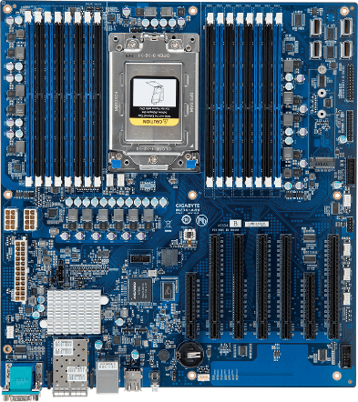

1. **Clearly label the following components (using arrows) on your image of the PC motherboard:**
   1. **CPU (and fan)**
   2. **RAM Memory**
   3. **Disk Drive Interface (IDE or SATA)**
   4. **GPU Graphics Processor (either on-board or Graphics Card)**
   5. **Sound Processor (either on-board or Sound Card)**
   6. **Wi-Fi / Ethernet Network Interface (either on-board or Graphics Card)**

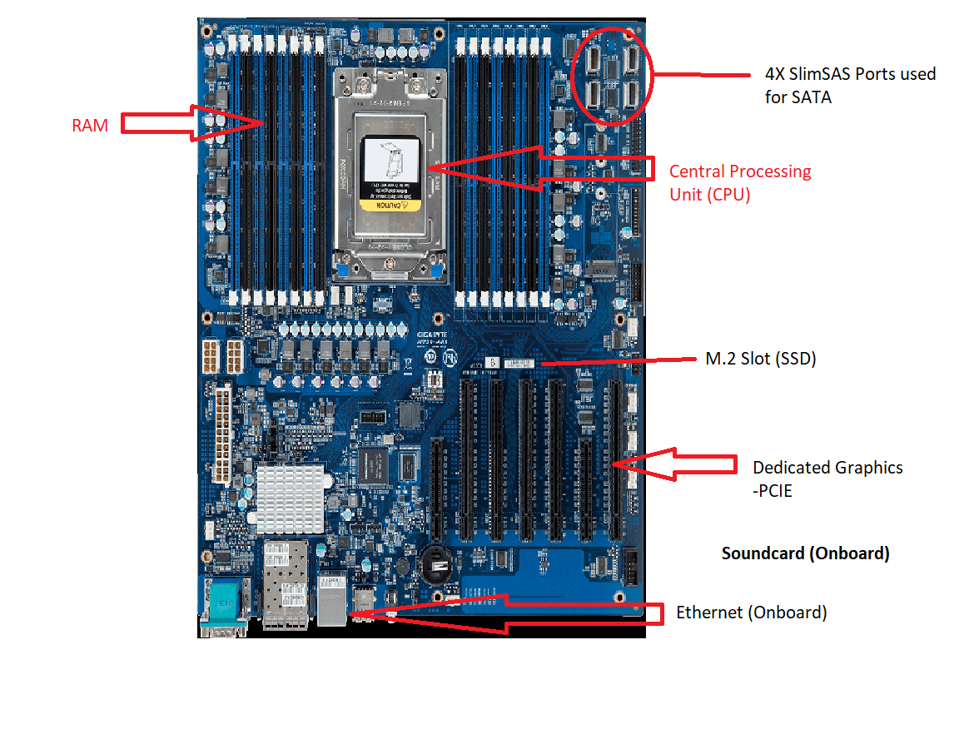

1. **Research more in-depth about “CPU Processor Chip”. Make notes on the following:**
   1. **What different versions are currently available (speed and capacity)**

**The processor chip in todays age has many kinds of varying speeds and different kinds of core counts. Today, most chips contain only 4 cores with 3.4 Ghz Furthermore, usually better processors have much higher speeds and core counts but is usually is worth a lot of money. Certain processors have a 6-core processor which can range from 8-32 cores. How the component has changed since the 1980’s**

**Since the 1980’s, the CPU had undergone many changes. Before, the CPU had only 1 core which ran at 6 Mhz which is significantly low compared to the modern-day processors. 10 years later during 1990, the speeds of the core slightly increased to 8 Mhz. Later on in 1990, the speed increased to 20 Mhz. Furthermore in 1995, the multi core processor was introduced to help build more processing power and functions. Overtime, the CPU started to increase in its speed and cores to make processing much quicker and bring much quicker speeds to any sort of task.**

**Level 3: Peripheral Devices**

**Outline**

**Learn about how peripheral devices are connected to the back side of a typical PC tower case. Examine physical samples, select and labeling images found on-line and gain deeper knowledge by researching and reporting on specific components.**

**Questions**

1. **Find one (or more) images that clearly show the layout of the back of a typical PC tower case.   
   (i.e. Google images using keywords “Back Of PC Tower”)**

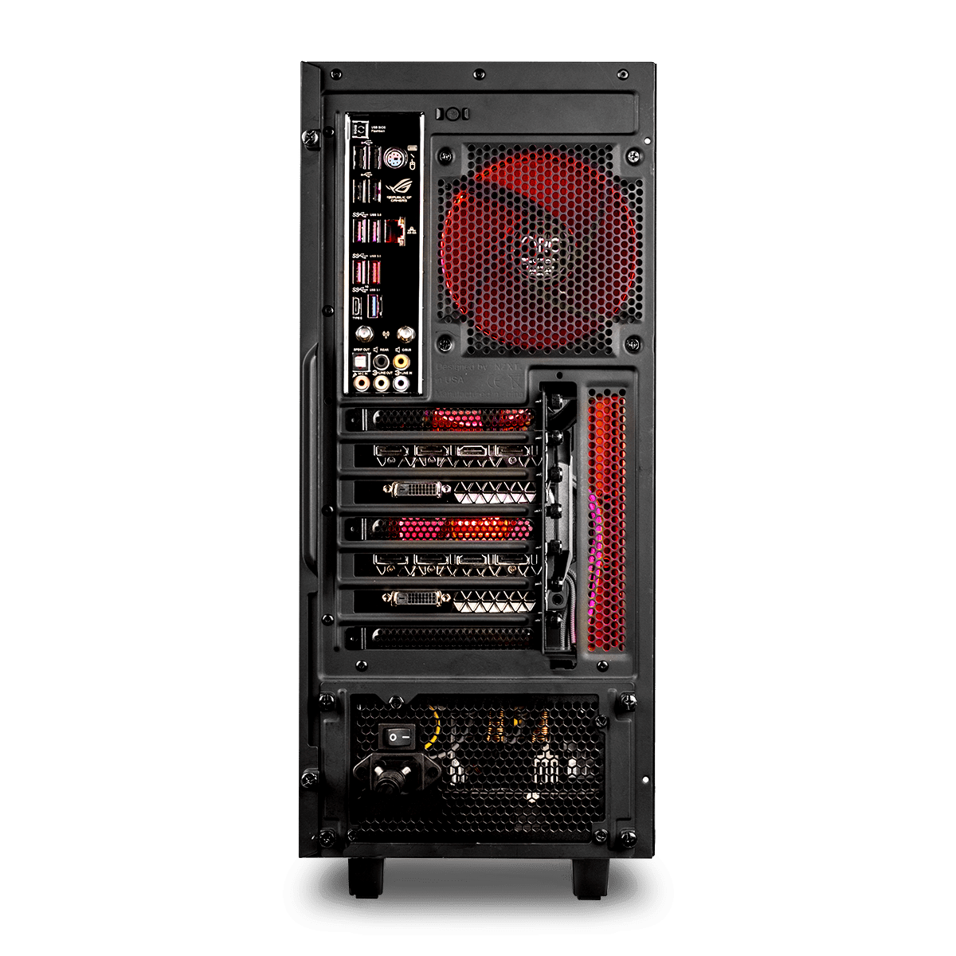

1. **Clearly label the following components (using arrows) on your image of the back of a typical PC tower case:**
   1. **Power cord and power switch**
   2. **Monitor Interface (VGA or DVI or HDMI)**
   3. **Mouse Interface (USB or PS/2)**
   4. **Keyboard Interface (USB or PS/2)**
   5. **USB Ports**
   6. **Audio Inputs / Outputs**
   7. **Ethernet Interface**

1. **Research more in-depth about “Monitor Technology”. Make notes on the following:**
   1. **What different versions are currently available (e.g. VGA / DVI, Flat Panel Technology))**

**There are many kinds of Monitor Technology. Monitor Technology has HDMI ports to help give a display for the monitor. Monitor Technology also includes a display port to display the image. Monitors have a variety of resolutions on pixel and pixel quality. The best being 4K (3840 x 2160) to display better pixel inch to bring much crisp and sharper looks. The more dots per inch there is, the higher the image quality will be.**

* 1. **since the 1980’s (e.g. Display Resolution, Technology)**

**Monitors have significantly changed from the 1980’s. Back then, monitors had very low resolution which provides low quality images which can only display black and white or black and green colors.**

1. **Research more in-depth about “External Portable Storage”. Make notes on the following:**
   1. **Floppy Disks- Magnetic disk that were used in the past for storing programs and data. Does not have much space.**
   2. **CD-ROM / DVD / Recordable CD/DVD- A lazer written, compact disk in which is used as storage.**
   3. **USB Memory Drives- Universal Serial Bus. Small device which can hold large amounts of data.**
   4. **Compact Flash Memory- Used to store the images taken from cameras. Can be from 1GB to 128GB**
   5. **Cloud Based Storage- A paid service used by a variety of companies in which can be used to access data from anywhere online.**